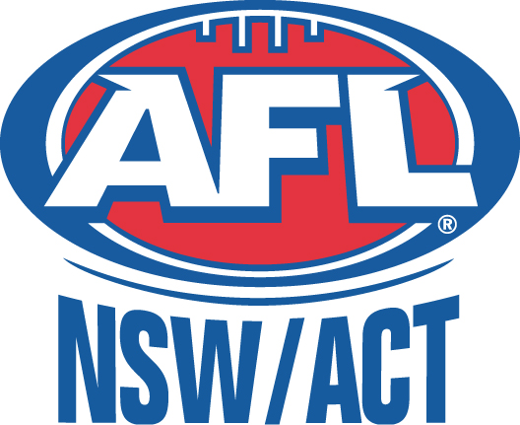

NCAS 2018/19 AFLW PROGRAM

Introduction
Thank you for your interest in applying for selection into the NCAS 2018/19 AFLW Program.

North Coast Academy of Sport (NCAS) is one of eleven regional academies throughout NSW. Supported by NSW Government - Office of Sport and Southern Cross University, NCAS with the support of AFL NSW/ACT undertakes the identification and development of talented junior AFL athletes on the North Coast of NSW.

The Academy AFL Program is within its second year and a major aim is to assist the individual development of each athlete so that they progress further in the sport. The 2018/19 program will commence in November/December 2018 and run to April 2019 (TBC). The program will have an emphasis on female athletes within U16 and U18 age groups (2001-2004). AFL NSW/ACT has recently revamped the female talent pathway with regional Academy of Sport programs providing the first step on this pathway which leads to selection to the NSW/ACT AFL State Teams to compete at National Championships.

As well as intensive training days, squad members also receive an athlete education program which includes sports nutrition, sports physiology, sports psychology and drugs awareness. Athletes will also be provided with an NCAS uniform.

Eligibility to Apply
To be eligible for NCAS selection, the athlete must meet the following criteria:
- Female athletes within U16 and U18 age groups (2001-2004)
- Reside in the in the North Coast region within the defined Local Government boundaries of the following Council areas: Clarence Valley, Coffs Harbour, Bellingen, Nambucca, Kempsey and Port Macquarie-Hastings
- Complete and submit application forms as attached by Friday 9th November 2018
- Display the potential to progress through the AFL NSW/ACT Athlete Pathway
- Demonstrate a dedication to improving performance

Program Format & Dates
The 2018/19 program is envisaged to have two centres – Northern (Coffs Harbour region) & Southern (Port Macquarie region) that will train independently of each other on a weekly basis – dependent on squad demographics. Both squads will also come together for combined sessions on a less frequent basis. Squad members will be required to attend the Your Local Club NCAS Education Program weekend (dates TBC) at Coffs Harbour as well as the Your Local Club Academy Games at Newcastle on 12th – 14th April 2019 (U16’s only) as part of their commitment to the program. The Your Local Club Academy Games will be used by AFL NSW/ACT as a selection opportunity for State teams.
State selection opportunities for athletes within U18’s will be confirmed shortly by AFL NSW/ACT.

Program dates will be advertised to selected athletes.

Expected Program Costs
Should you be selected for the 2018/19 program you can expect to pay a fee of approximately $200.00 to confirm your place in the squad. The fee may be paid over instalments and payment plans may be negotiated if required.
The estimated program cost will cover the following:
- Athlete Insurance
- Administration Costs
- Uniform
- Venue Hire
- Equipment
- Coach Travel expenses
- Entry to the 2019 NCAS Academy Awards Evening, including meal
- Entry to the Your Local Club NCAS Education Program weekend, including meals, (formally RACE) where sport education modules will be delivered.

Athletes will need to organise and pay for their own travel, accommodation and meals as required to the training days, NCAS events and Academy Games. Each athlete will have the contact details for fellow squad members so carpooling, etc. can be organised.

There will be a separate athlete levy for U16 athletes attending the 2019 Your Local Club Academy Games which will cover the following: athlete insurance, team registration, coach expenses, welcome pack

NCAS AFLW Personnel
The NCAS AFLW Program is overseen and run by:

- AFL NSW/ACT delegate
- NCAS Coach/es
- NCAS Executive Staff

Please ensure at least one active email address is provided on your application.
Applications close Friday 9th November 2018. No late applications will be accepted.
Applicants who have satisfied the eligibility criteria and have demonstrated the skills necessary to be a part of the program will be notified within two weeks of application closing date via email.

Best Wishes,

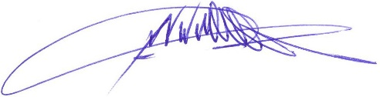

John Kincade
Executive Director


157 Lismore NSW 2480
Ph: (02) 6620 3073
Fax: (02) 6620 3707
Email: programs@ncas.org.au
Web: www.ncas.org.au
ABN: 19 536 201 275

APPLICATION FORM
NCAS AFLW Squad 2018/19

All applications to be submitted to: programs@ncas.org.au
Instructions to AFL athletes wishing to attend weekend:
- Complete all sections
- Write neatly using only black pen or digital completion
- Return this completed form & payment slip back to NCAS by Friday 9th November 2018

Applicant Details
Full Name
Email (athlete)
Street Address
Town & Postcode
Date of Birth
Gender
Home Phone
Mobile Phone (athlete)
Email (parent / guardian)
(1) Parent/Guardian Name
Above Persons Contact no.
(2) Parent/Guardian Name
Above Persons Contact no.
Other Emergency Contact Person & Contact Number
ATSI-Diverse Background (Optional):
Are you of Aboriginal, Torres Strait Island or other culturally diverse background? Yes / No
This information is used for NSW Government – Office of Sport reporting requirements
School
Playing Position (2 only)
Height (cm)
AFL Club Name
I’m applying to be part of (please circle): | Port Macquarie Centre / Coffs Harbour Centre
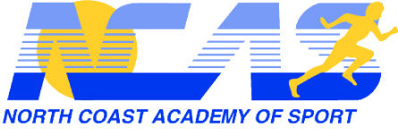
North Coast Academy of Sport
ATHLETE MEDICAL FORM

2018/19 AFLW Squad

Complete the medical information below.

NCAS treats this information as confidential and is bound by its privacy policy. NCAS will only distribute this information to those people whom we consider need it to ensure your health and well-being at NCAS events.

Please attached additional pages if required.

If you wish to discuss any matters on this form, please contact NCAS on (02) 6620 3073.

Field | Print Neatly In Black Ink
Athlete Full Name
Medicare Number
Do you have private medical cover?
If yes, state provider and policy number
Do you have ambulance cover?
Date of last tetanus injection
Blood type
Do you suffer from asthma?
If yes, detail your treatment plan
Do you suffer from diabetes?
If yes, detail your treatment plan
Do you suffer from epilepsy or similar episodes?
If yes, detail your treatment plan
Do you suffer from allergies (foods, medications, stings etc)
If yes, detail your treatment plan/s
Do you have any specific food requirements (gluten free, vegetarian, vegan etc)
List any other personal medications and the reasons for their use.
List all other medical / health related matter/s not already mentioned that NCAS should be made aware of as well their related treatment plan/s
Detail all significant injuries and treatments over the past 12 months.
Parent/Guardian contact name and number
Best emergency contact name and number
Parent's / Guardian's Name (print):

Parent's/Guardian's Signature: Date

